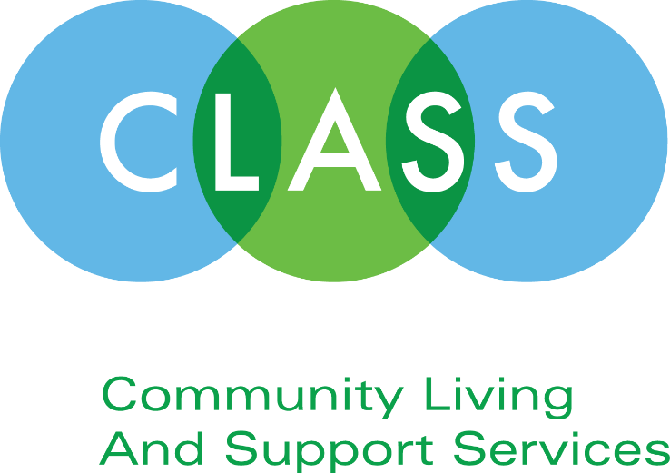

3D Printed Assistive Devices Catalog

Table of Contents

How to Get Device ------------------------------------------------------------------------------------------ 3

Bag Holder --------------------------------------------------------------------------------------------------- 4

Book Holder ------------------------------------------------------------------------------------------------- 5

Boomerang Bottle Opener --------------------------------------------------------------------------------- 6

Can Handle --------------------------------------------------------------------------------------------------- 7

Finger Pen Holder ------------------------------------------------------------------------------------------- 8

Fork/Spoon Aid ---------------------------------------------------------------------------------------------- 9

Key Turner -------------------------------------------------------------------------------------------------- 10

Palm Pen Aid ----------------------------------------------------------------------------------------------- 11

Reading Bar ------------------------------------------------------------------------------------------------- 12

Signature Aid ----------------------------------------------------------------------------------------------- 13

Zipper Aid A ------------------------------------------------------------------------------------------------ 14

Zipper Aid B ------------------------------------------------------------------------------------------------ 15

Zipper Aid C ------------------------------------------------------------------------------------------------ 16

How to Get a Device
- Browse the catalog of devices available to be printed
- Pick out which device(s) you would like to receive
- Contact Olivia Shope at oshope@classcommunity.org and include which device you would like to receive
- Schedule a time to come pick up the device
- Stop by the CLASS office to pick up device
  - If you would like to take part in the capstone project, sign consent form and fill out the demographics survey at this time as well
- Take your device home and enjoy!
- If you are taking part in the capstone project, Olivia will schedule a second meeting time in 3-4 weeks to review your satisfaction with the service and the device. This can be done virtually
*If you have questions about the devices or the capstone project please email Olivia at oshope@classcommunity.org*
*If you want to request a device that is not in the catalog, please reach out to Olivia at oshope@classcommunity.com, we will do our best to accommodate these requests but cannot guarantee that they can be printed at CLASS*
Bag Holder

Description: A device that makes it easier to carry multiple bags. Works best if the bags are balanced.
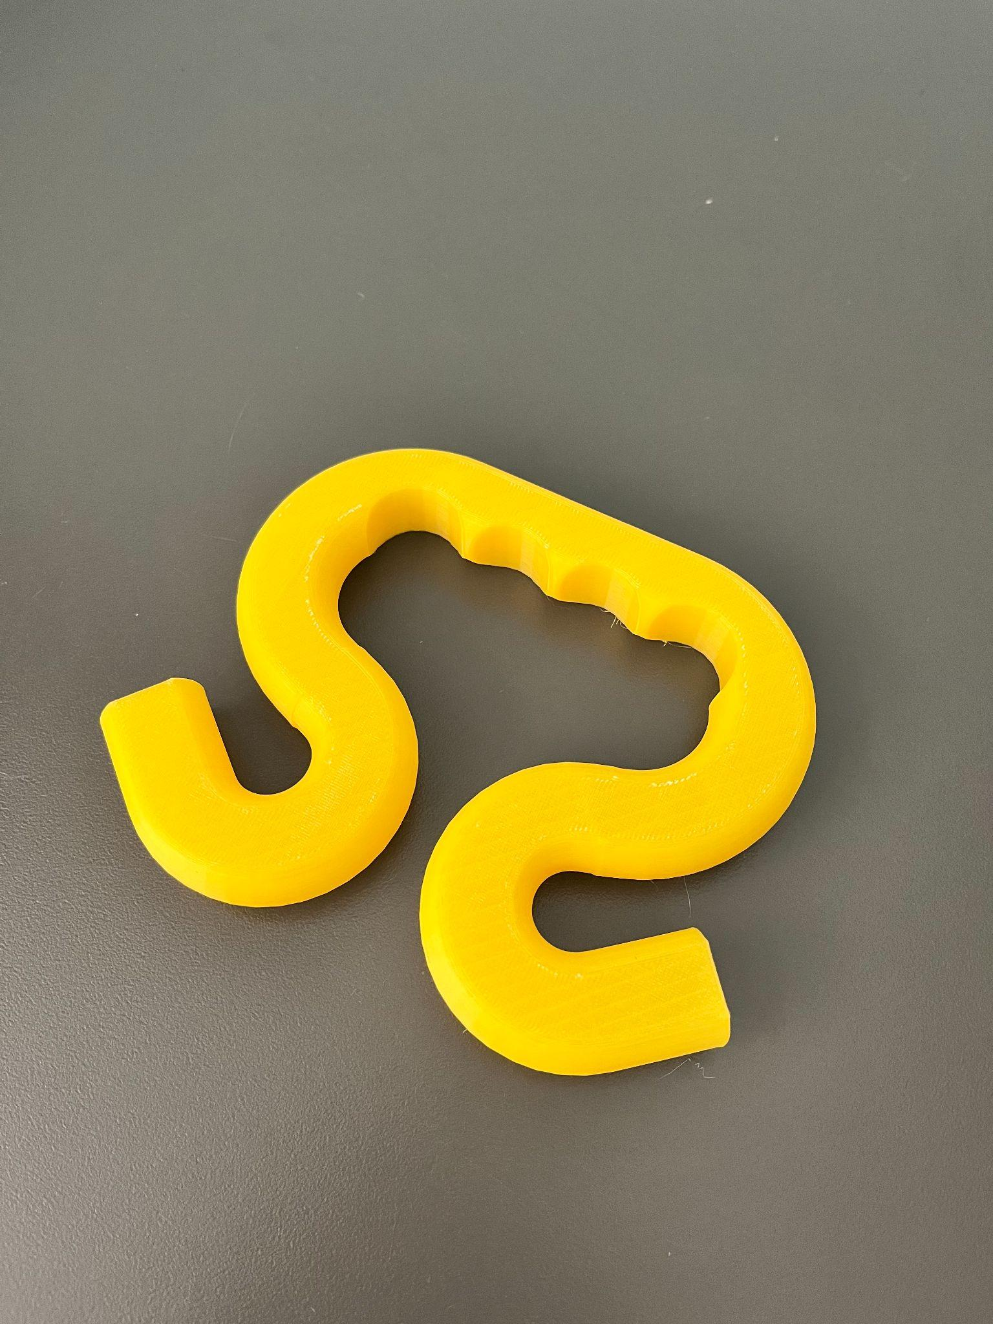
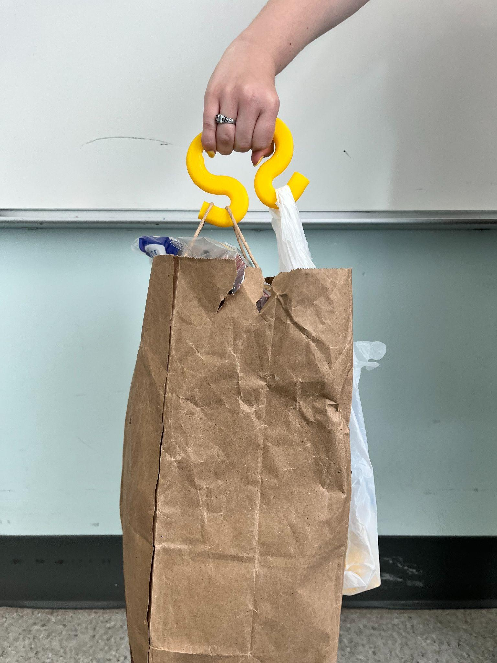
Book Holder

Description: A device that helps to hold a book open using one hand. Great for paperbacks and small hardback books.
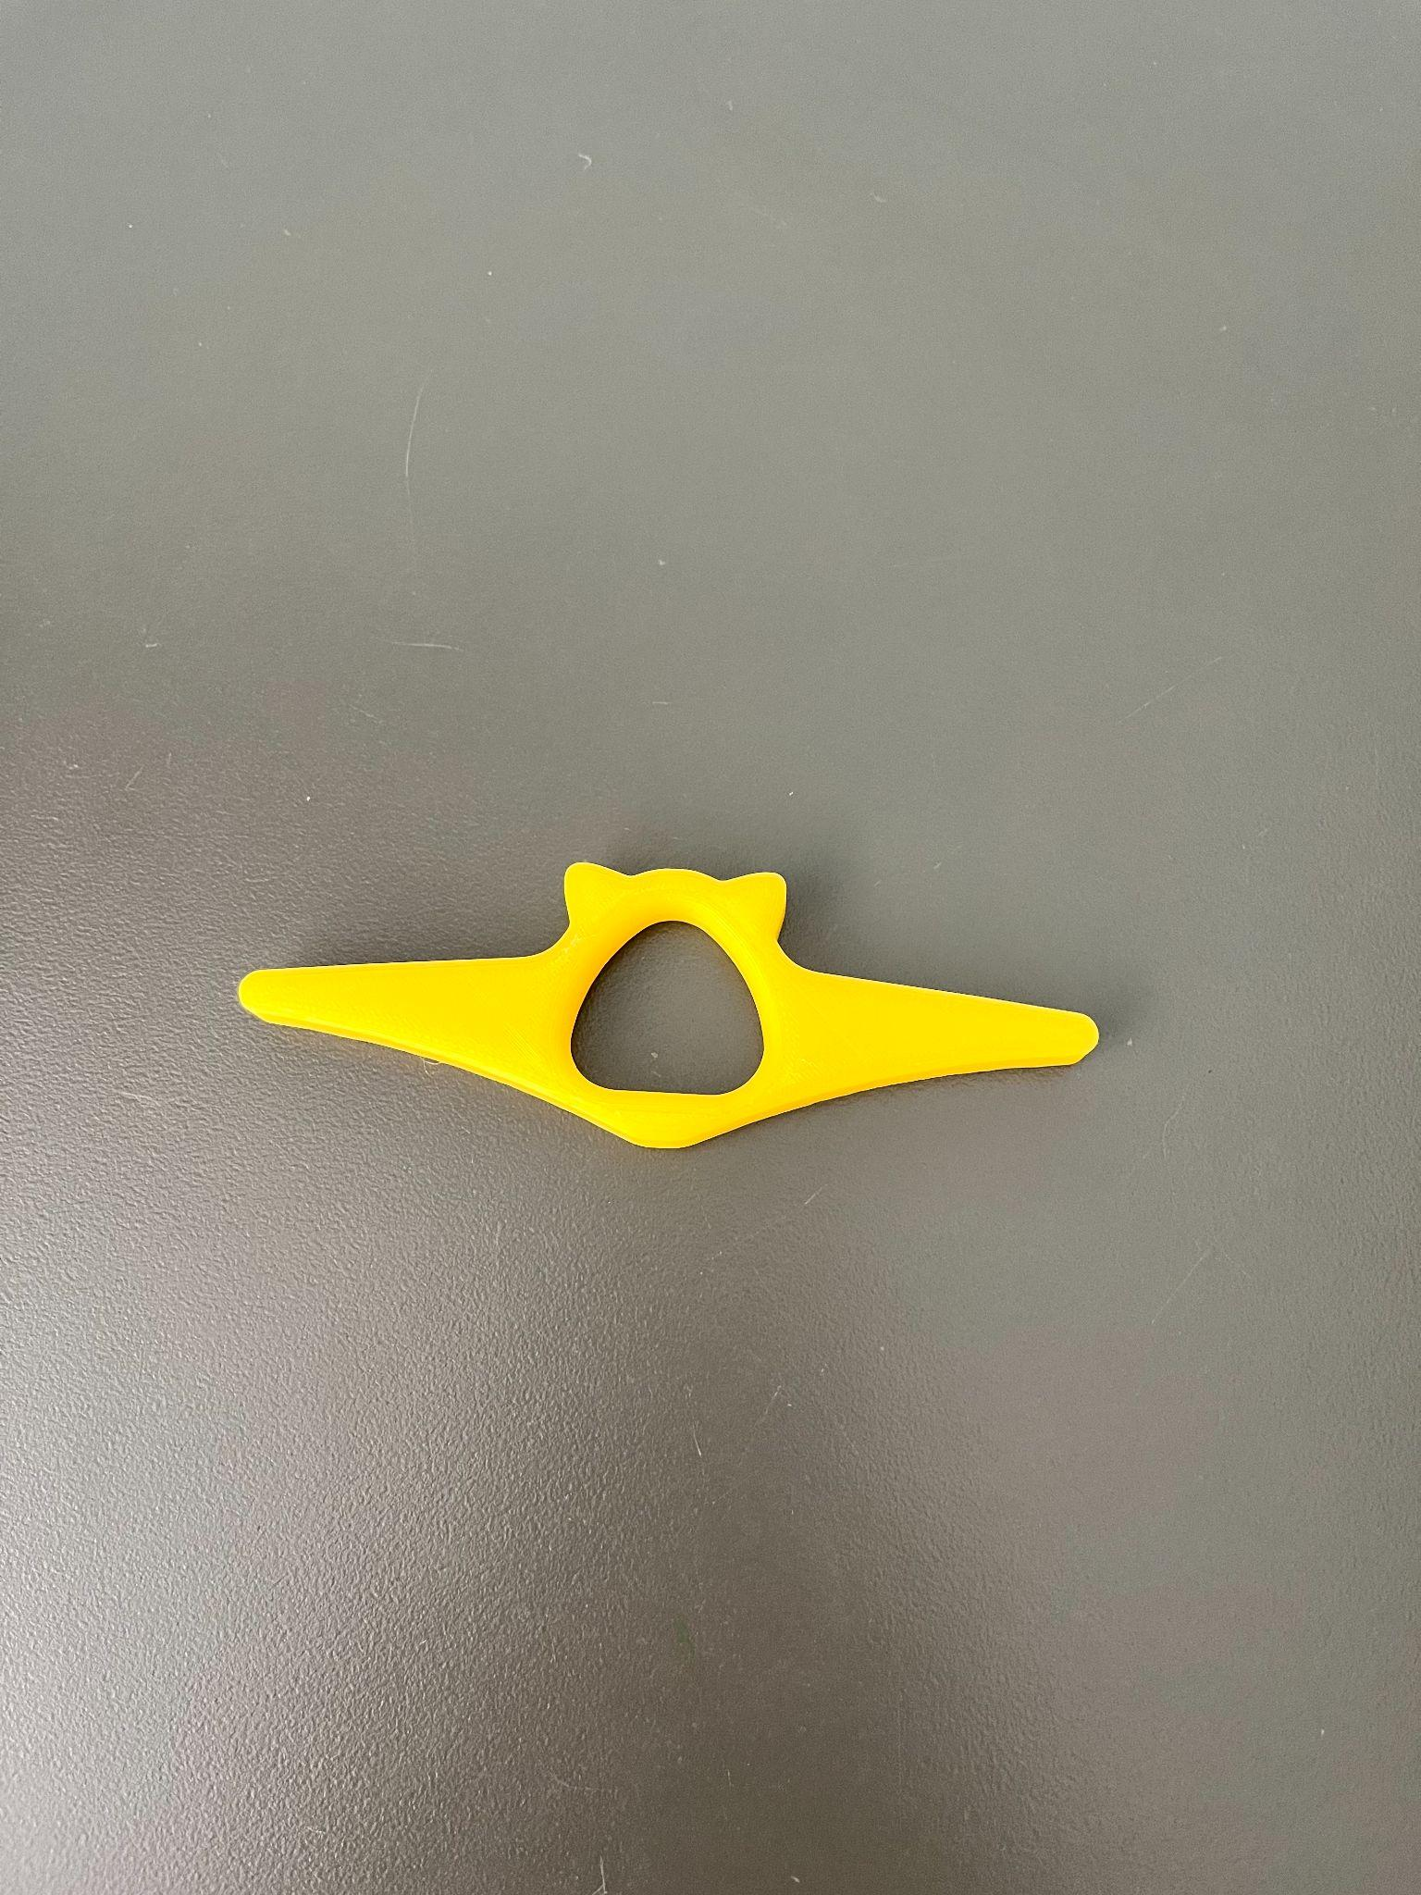
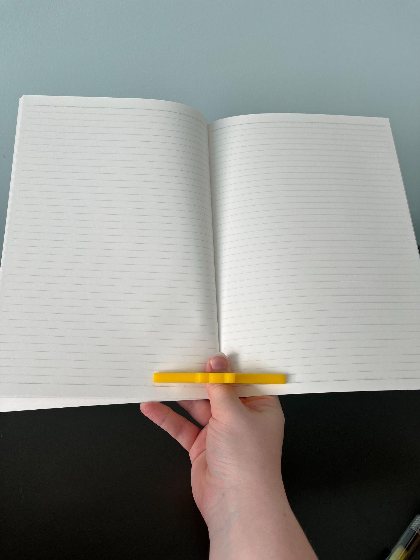
Boomerang Bottle Opener

Description: A device for opening bottles. The boomerang shape makes it easier to hold, works best on water and soda bottles.
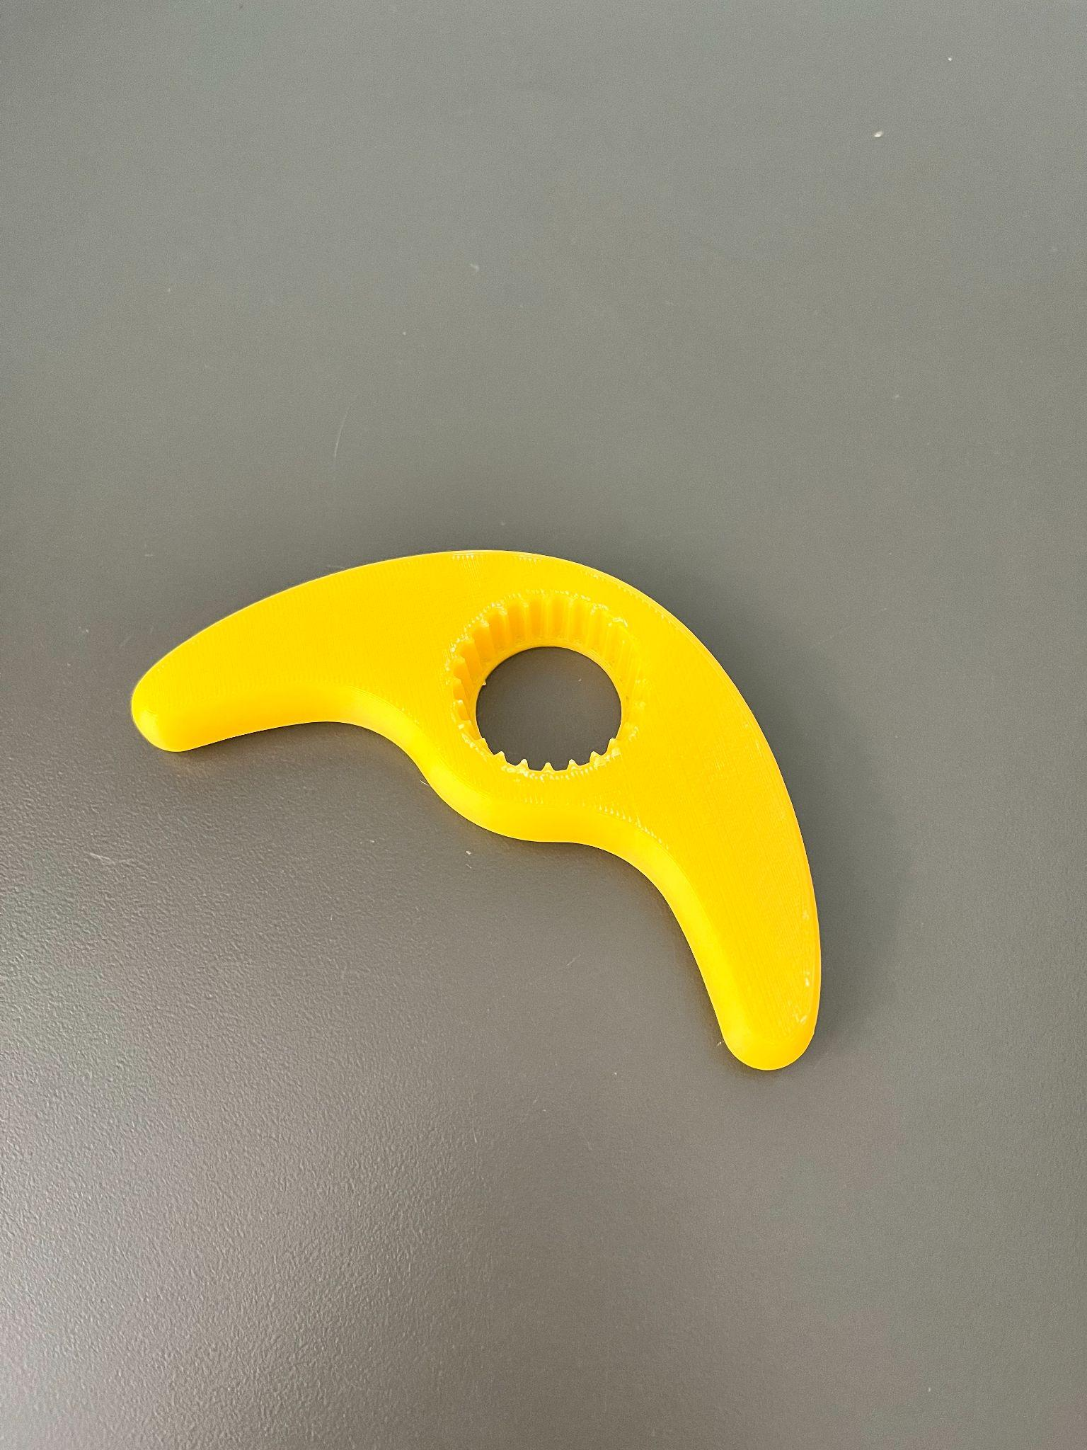

Can Handle

Description: A device that puts a handle onto a can, makes it easier to hold. Fits a standard 355 ml can.
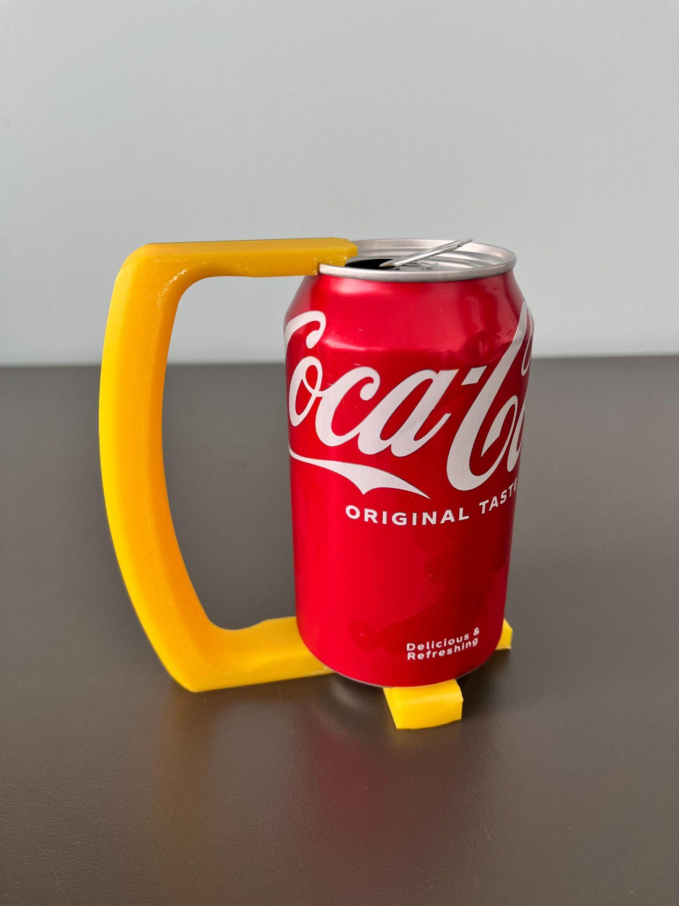
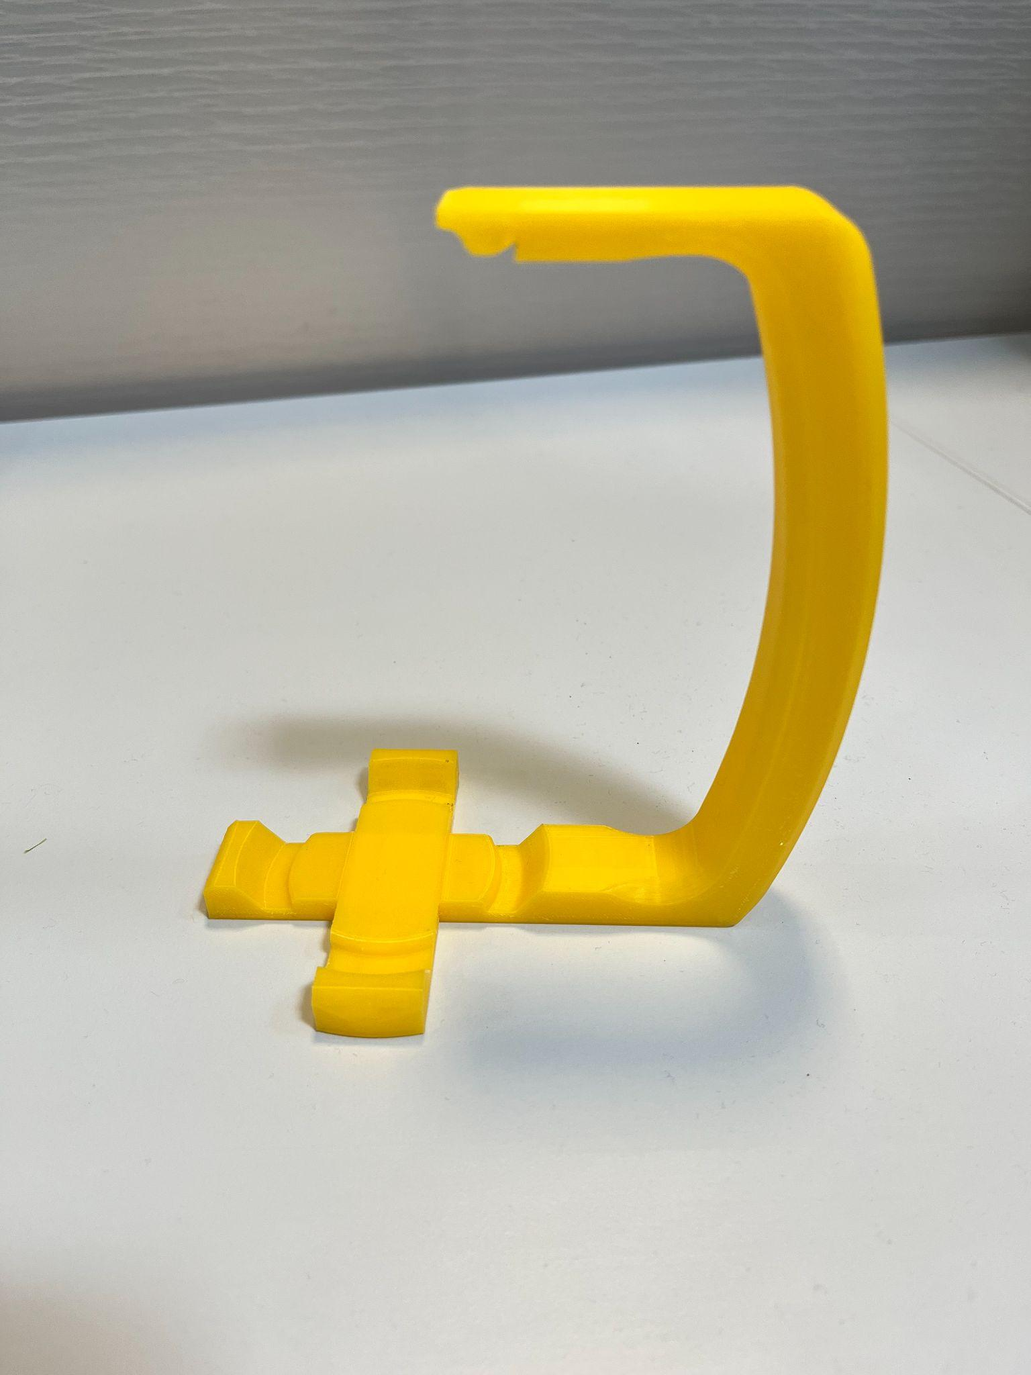

Finger Pen Holder
Description: A device that rings around the index finger to hold a pen in a tripod grasp. The pen snaps into the smaller loop.
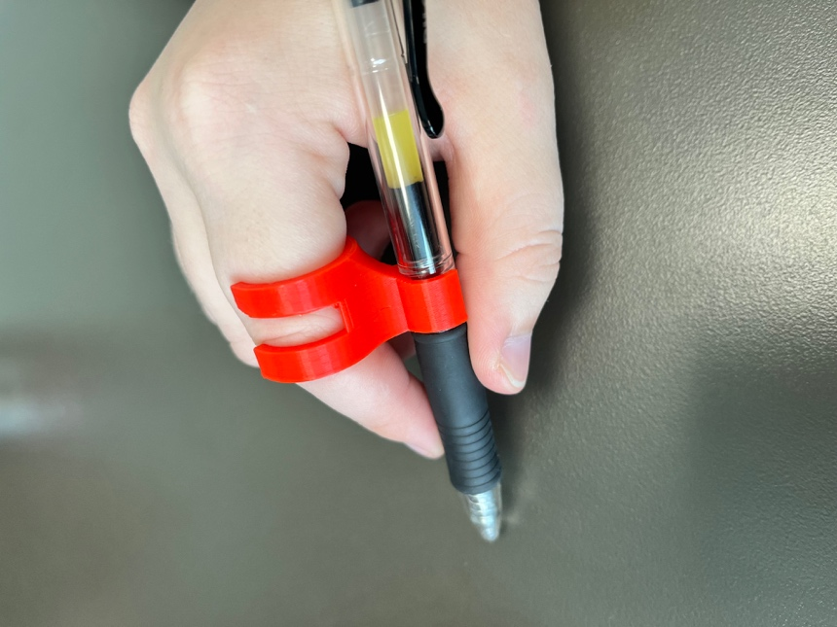
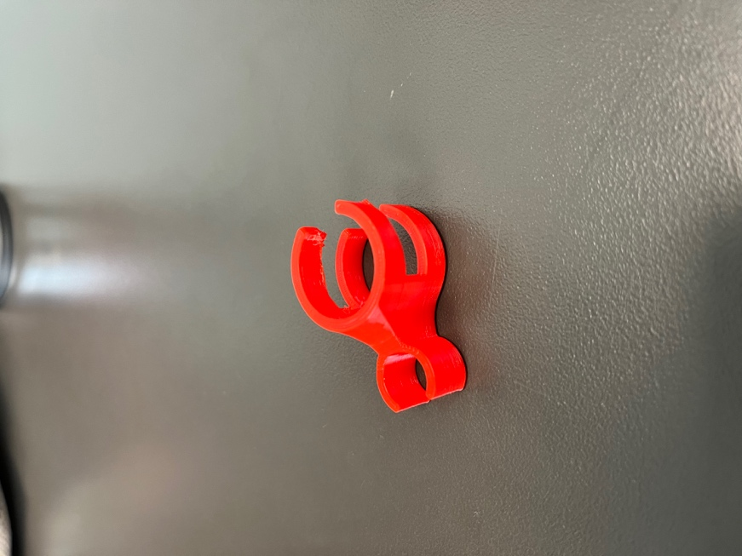
Fork/Spoon Aid

Description: A device that acts as a cuff to make it easier to hold eating utensils.
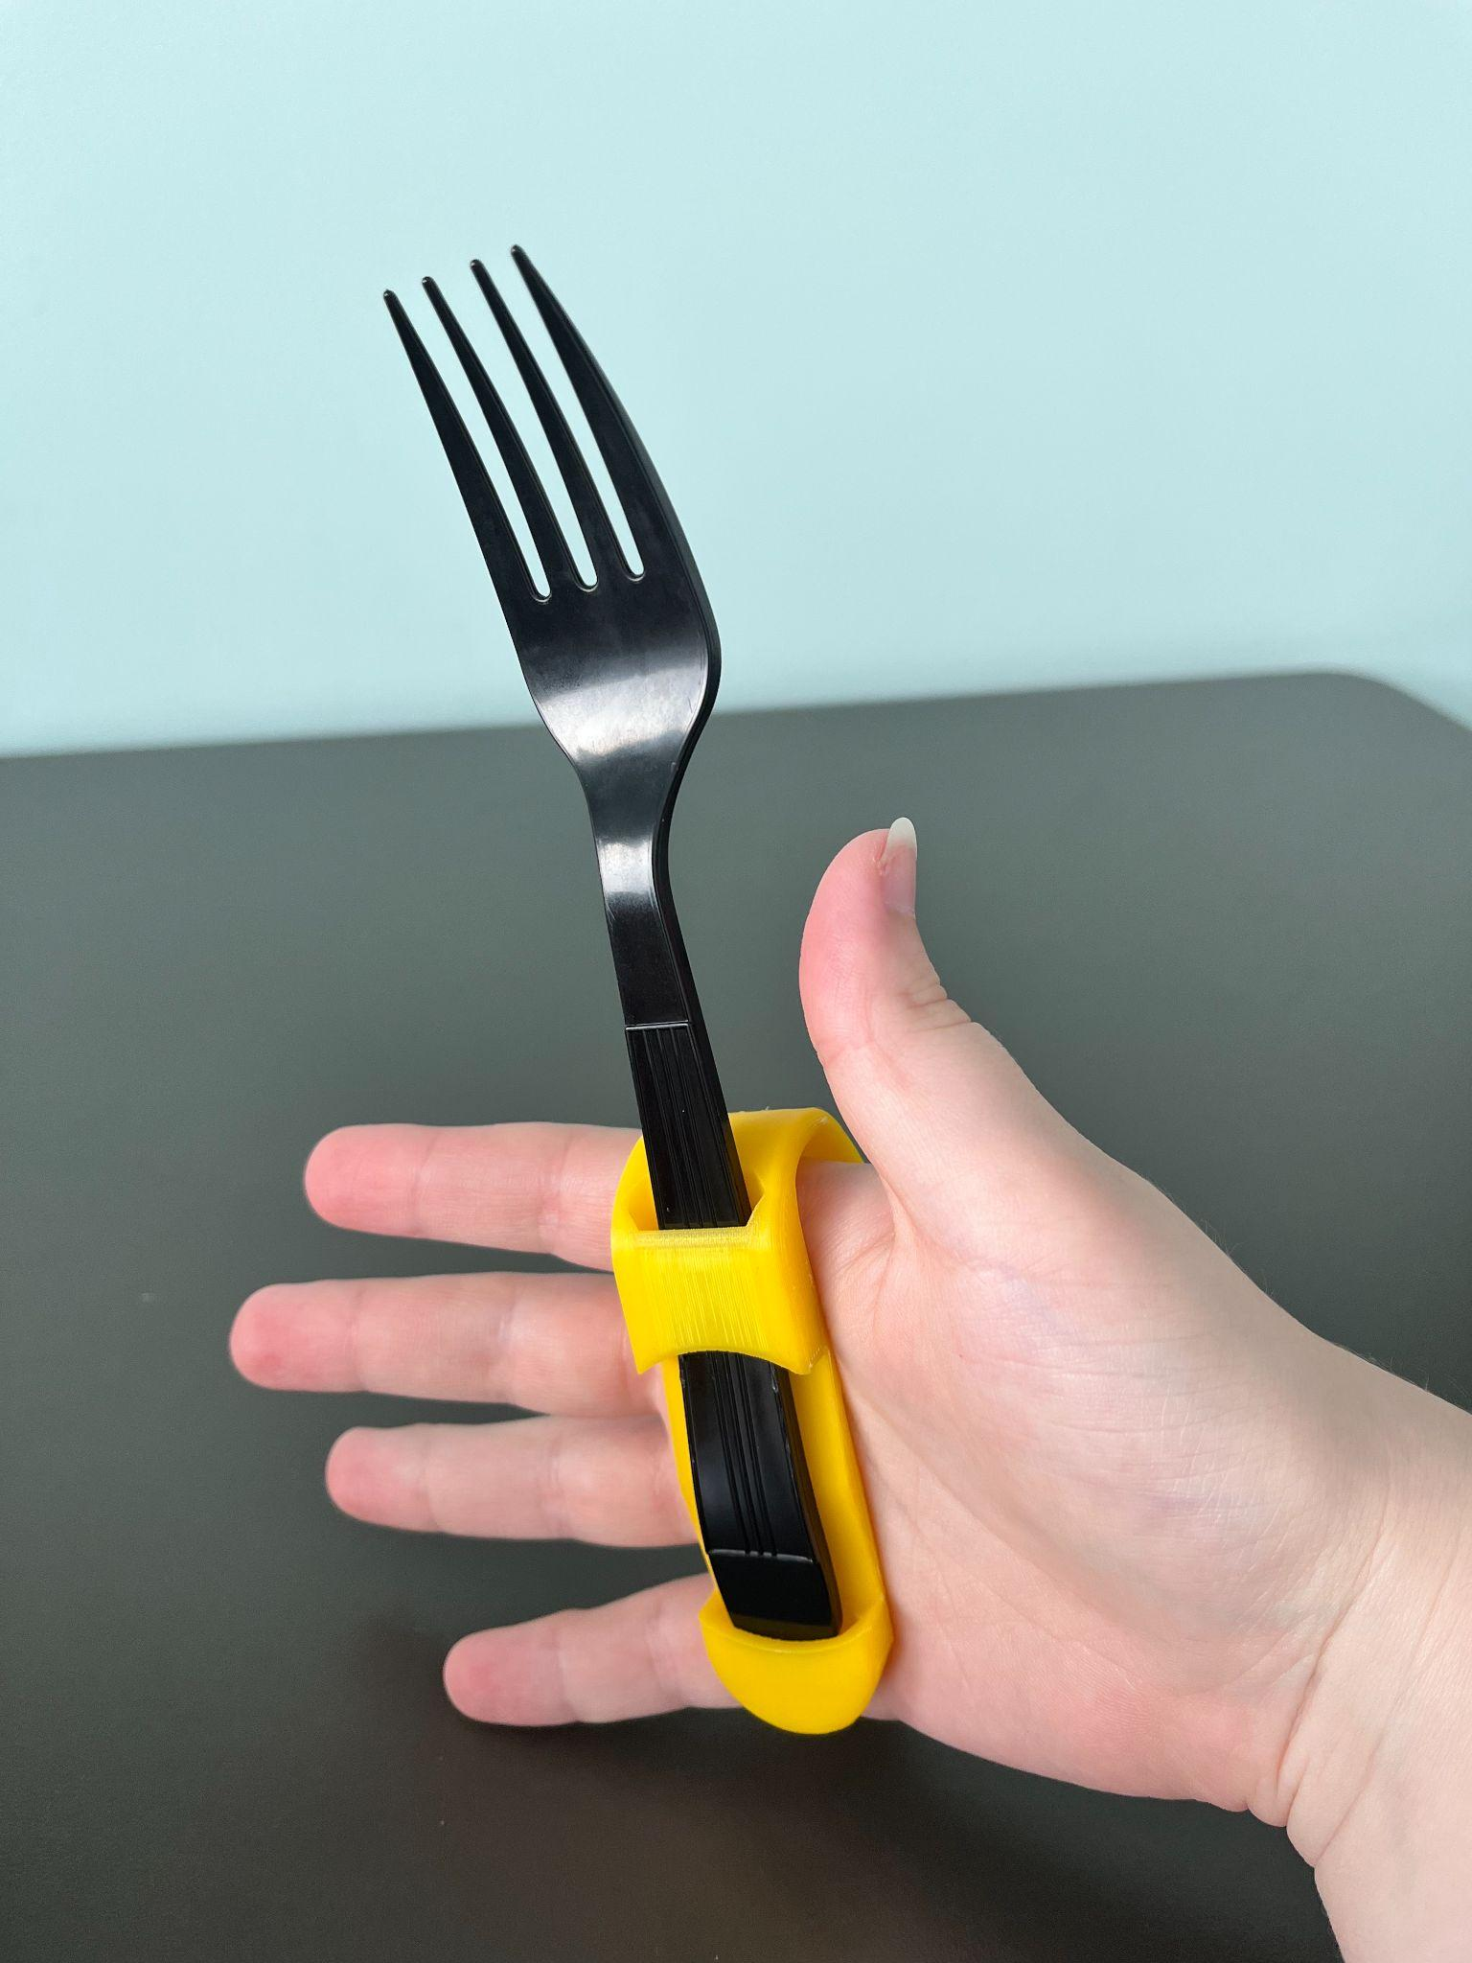
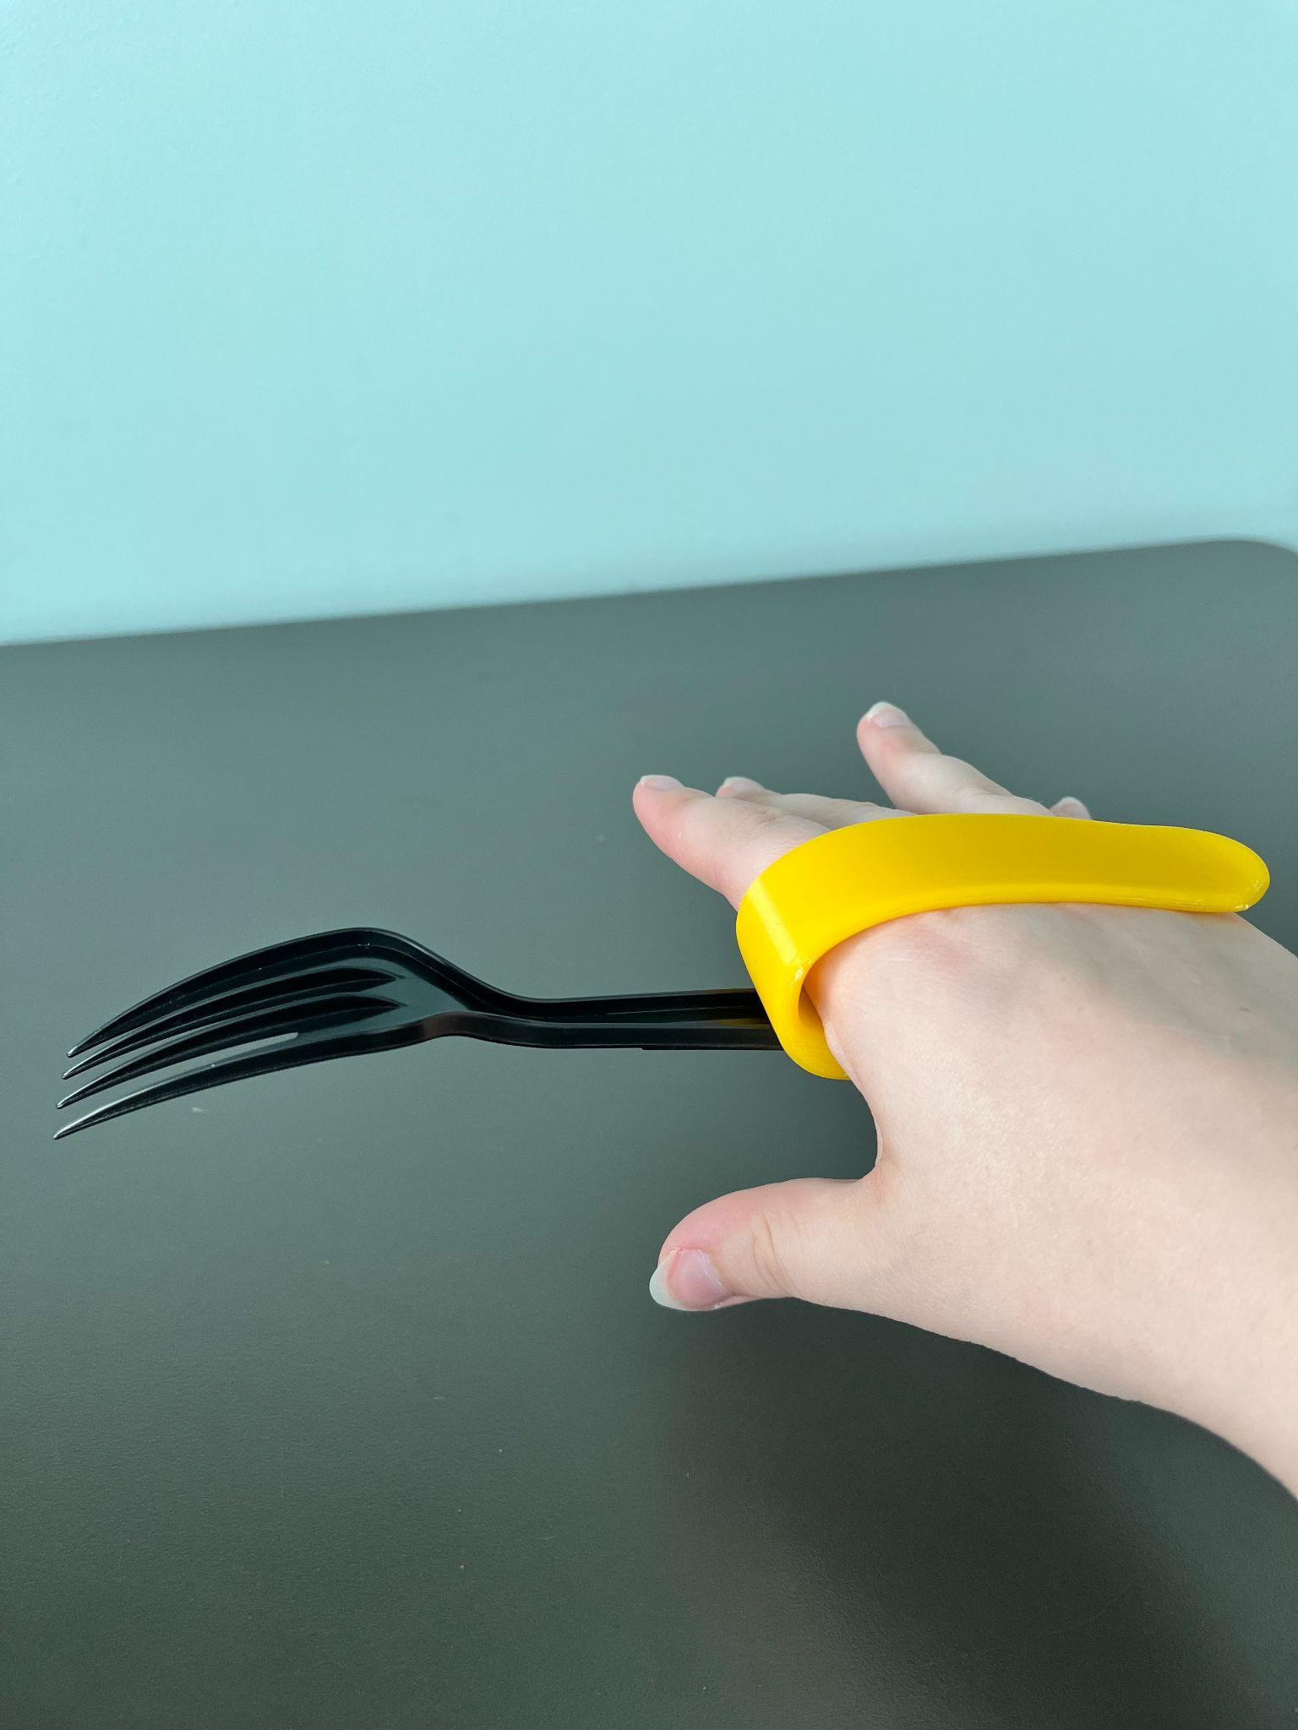
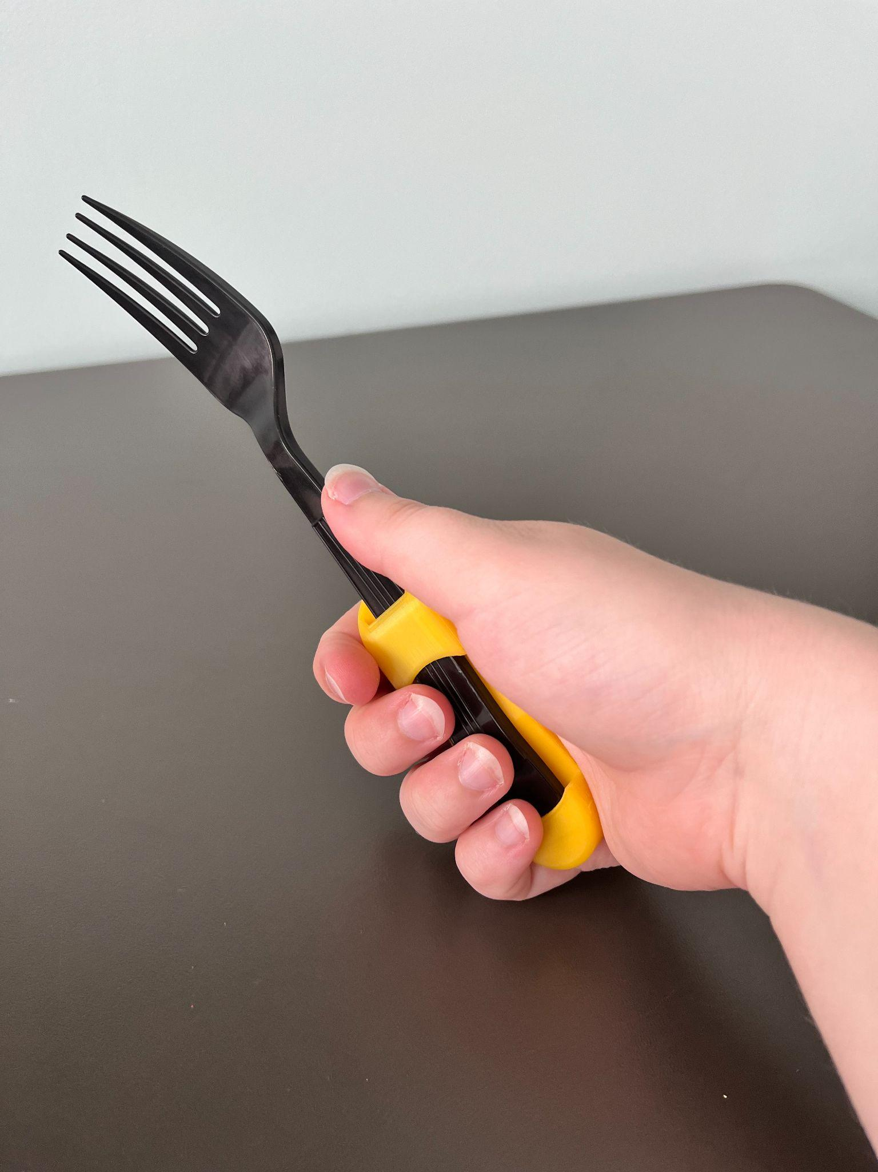
Key Turner

Description: A device that attaches to a key to give a better grip and make it easier to turn in a lock. Key is bolted onto the drive with a screw.
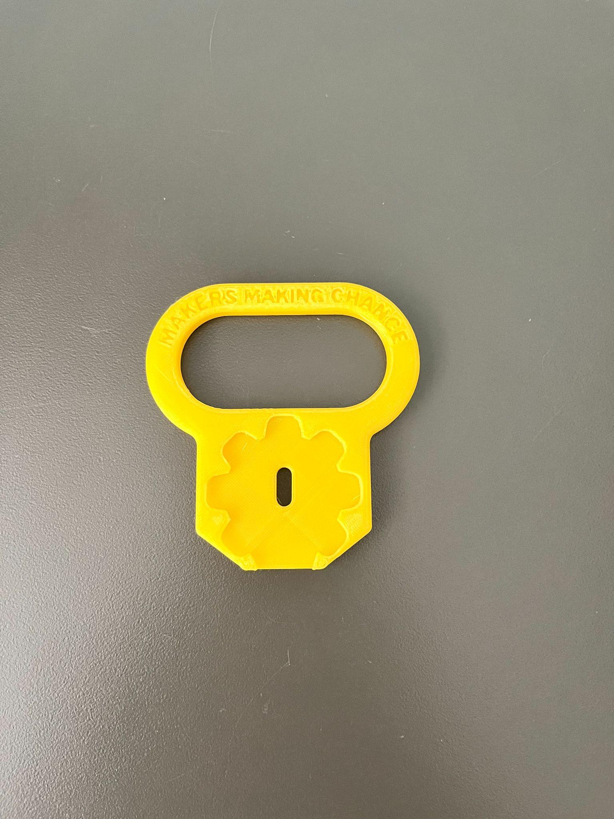
Palm Pen Aid

Description: A device that acts as a cuff to make it easier to hold a pen or pencil.
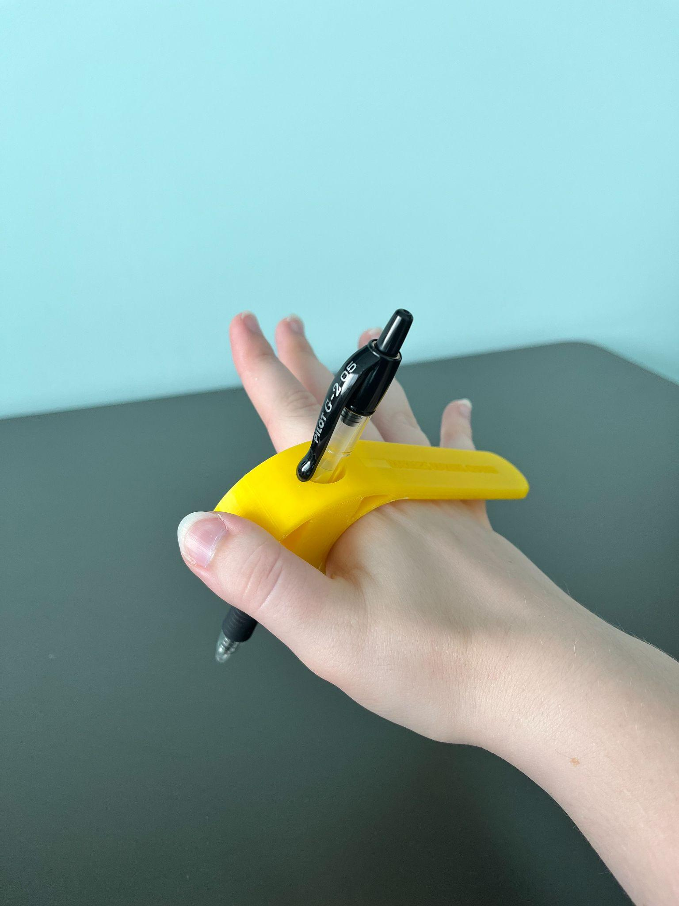
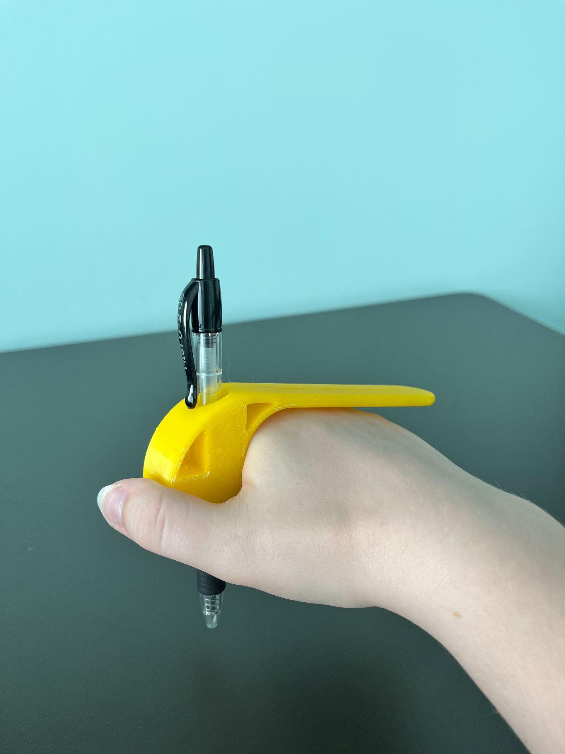
Reading Bar

Description: A device that helps to isolate text on a page to make it easier to focus on reading one or two lines.
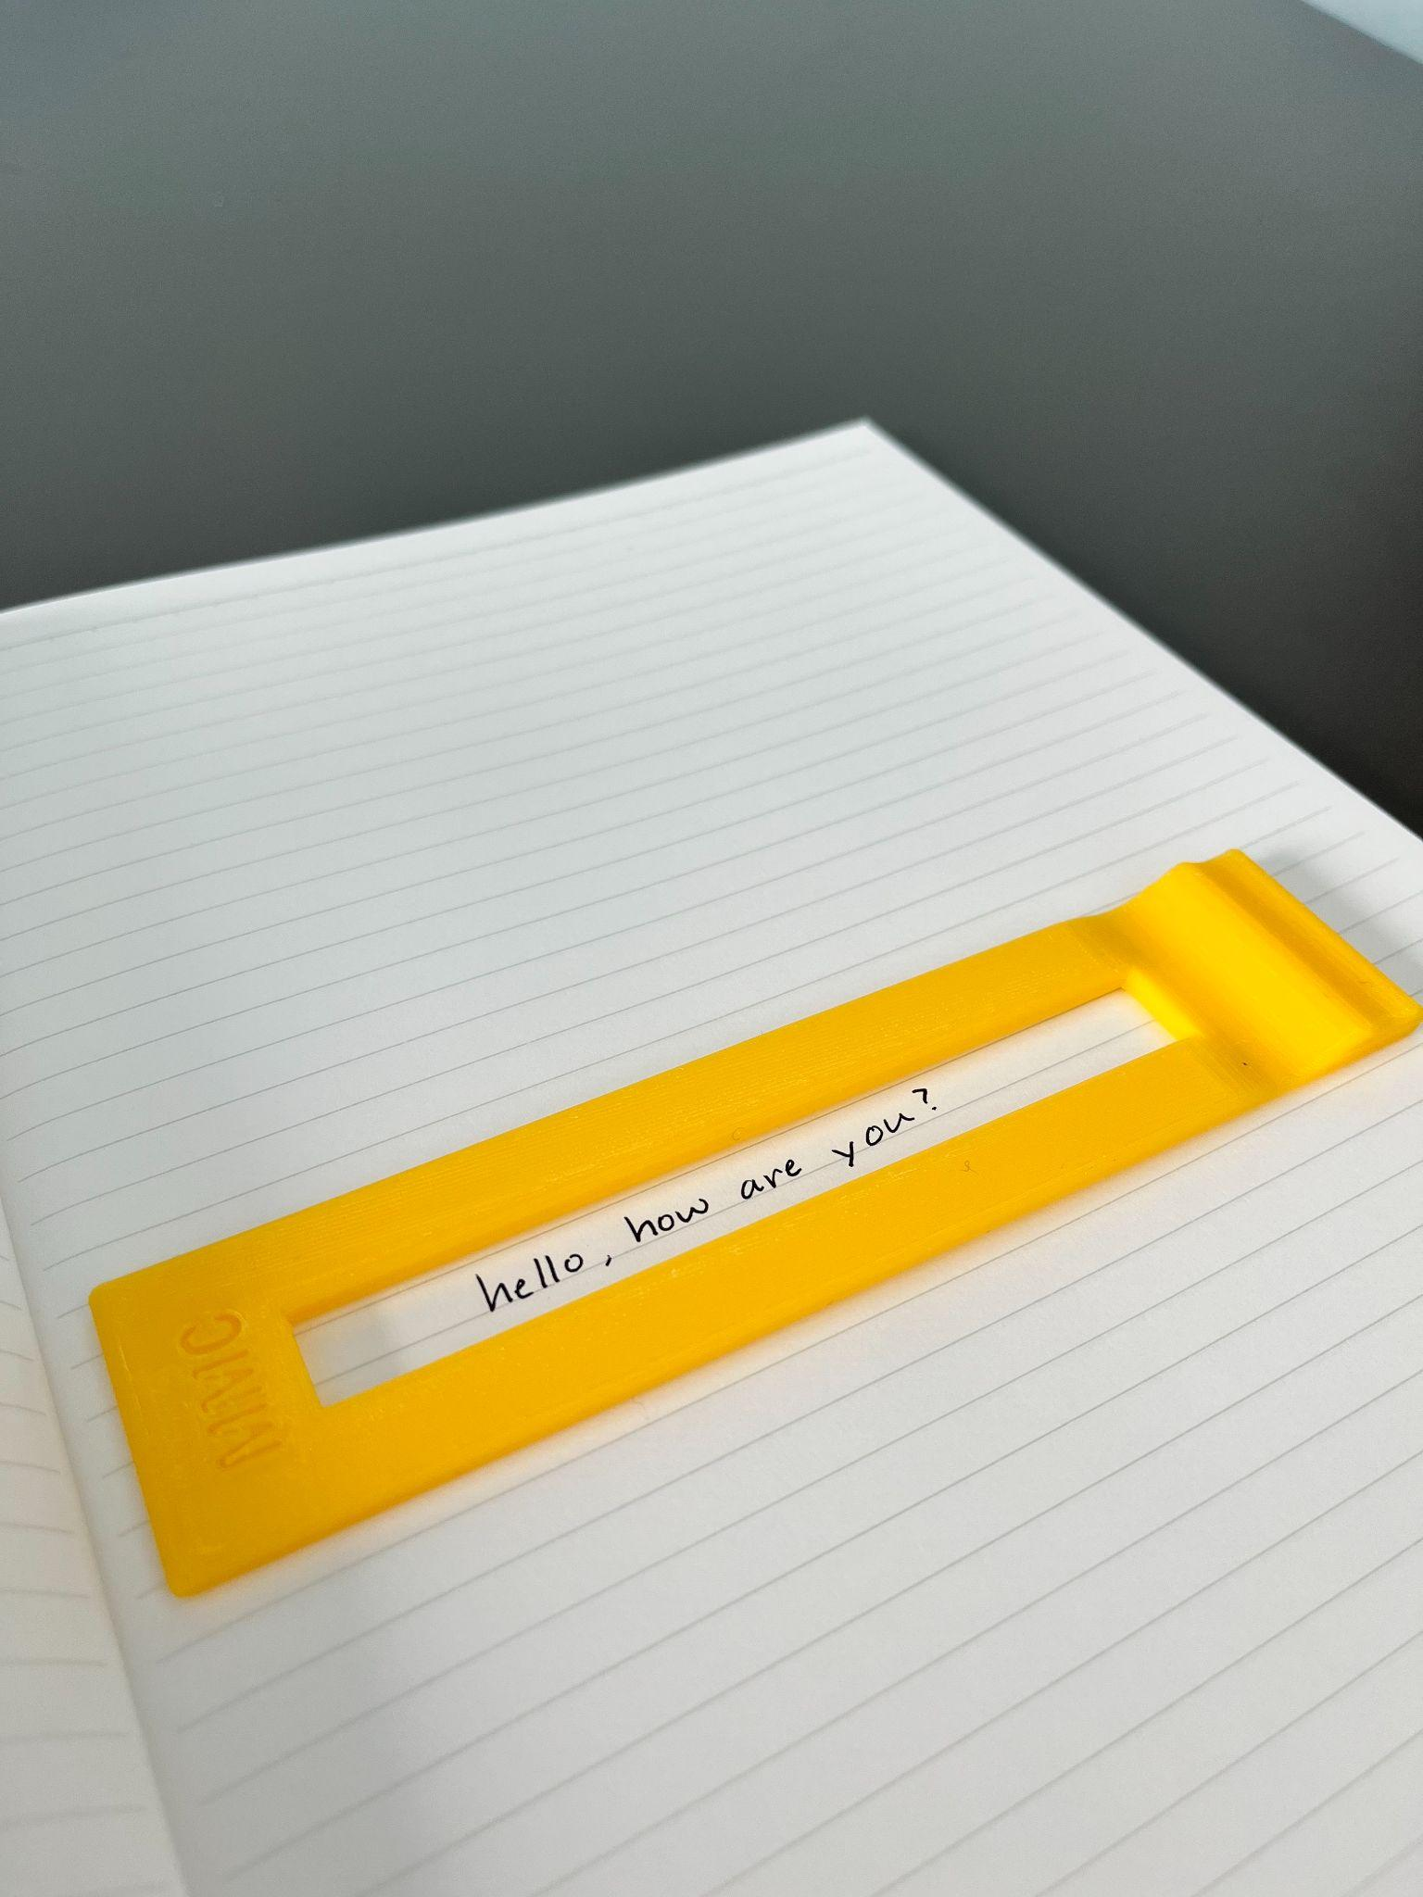
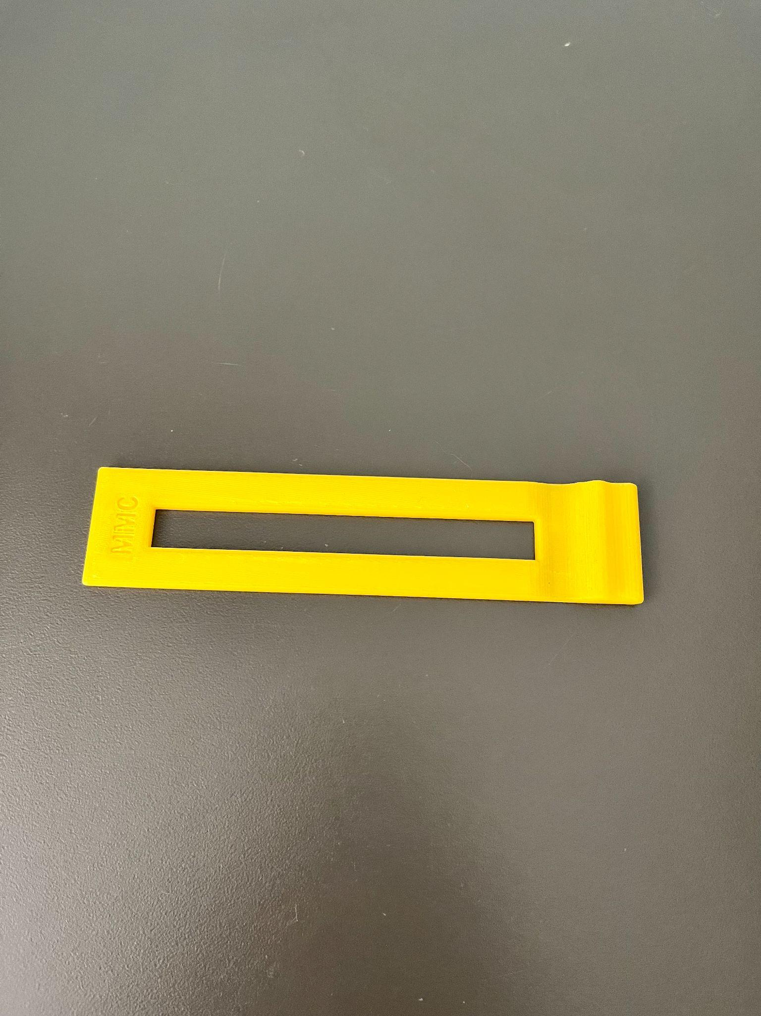
Signature Aid

Description: A device that makes it easier to sign a name or write in a particular space. It has boxes of different sizes and can fit in a wallet.
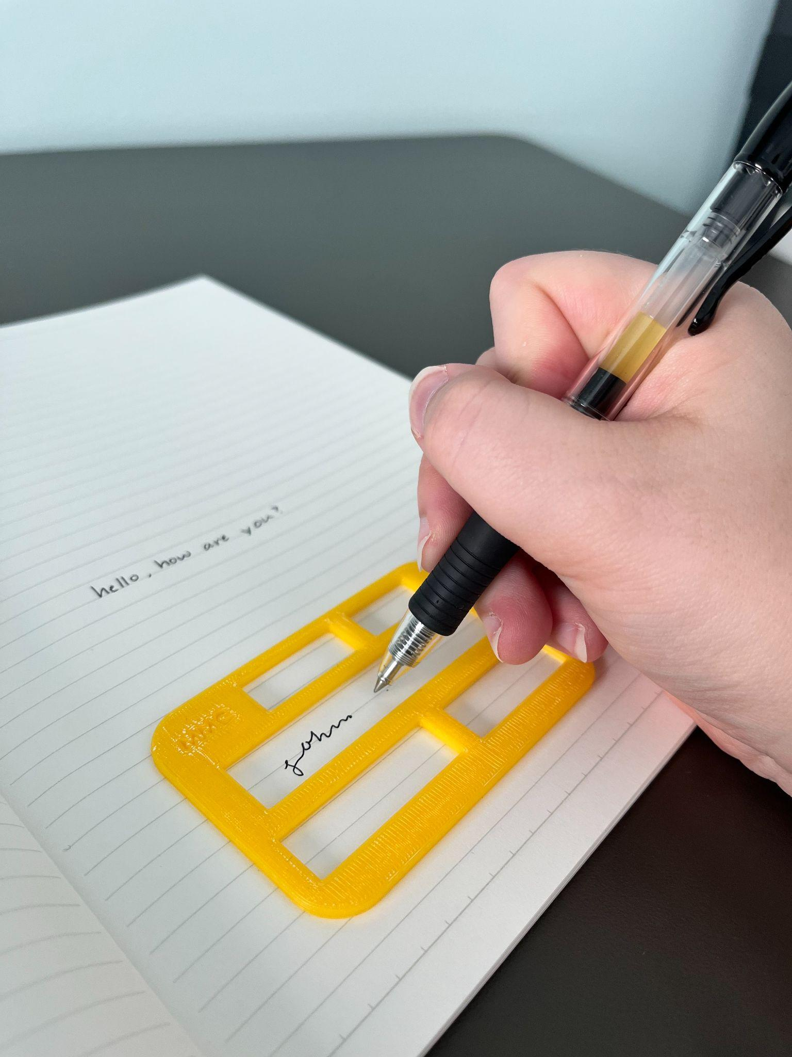
Zipper Aid A

Description: A device that makes it easier to use a zipper. It increases the size of the zipper and provides a larger hole allowing for a better grip. The zipper aid is attached using zip ties. Version A is the smallest one available and fits a smaller zipper size.
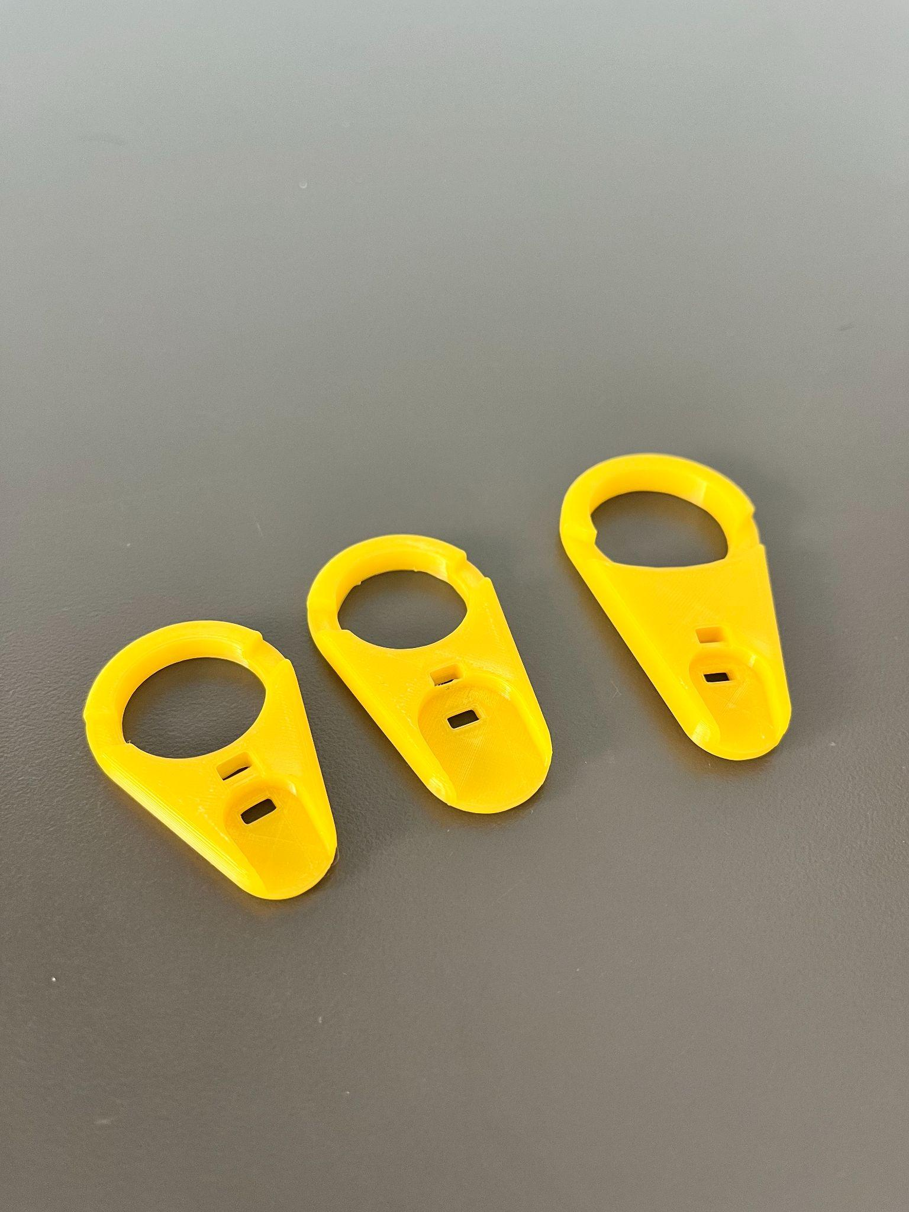
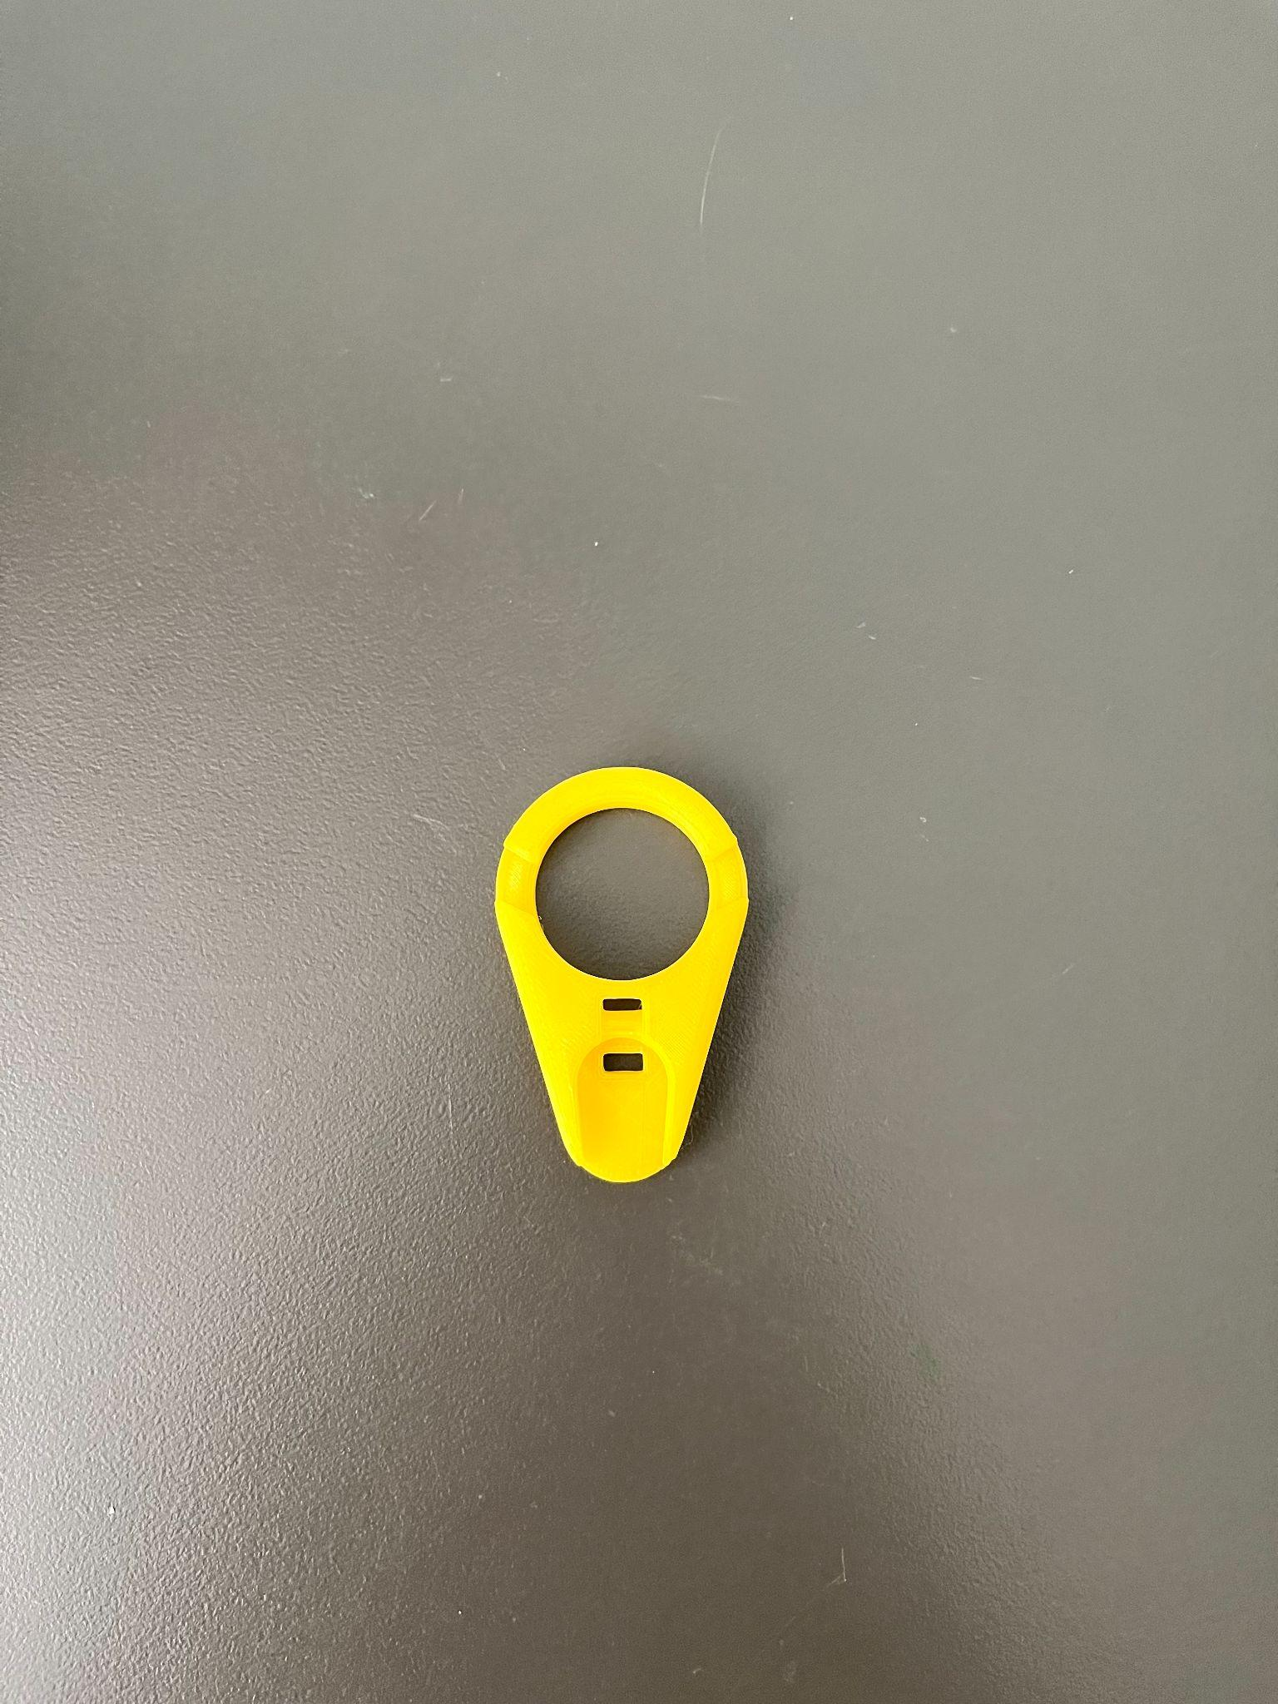
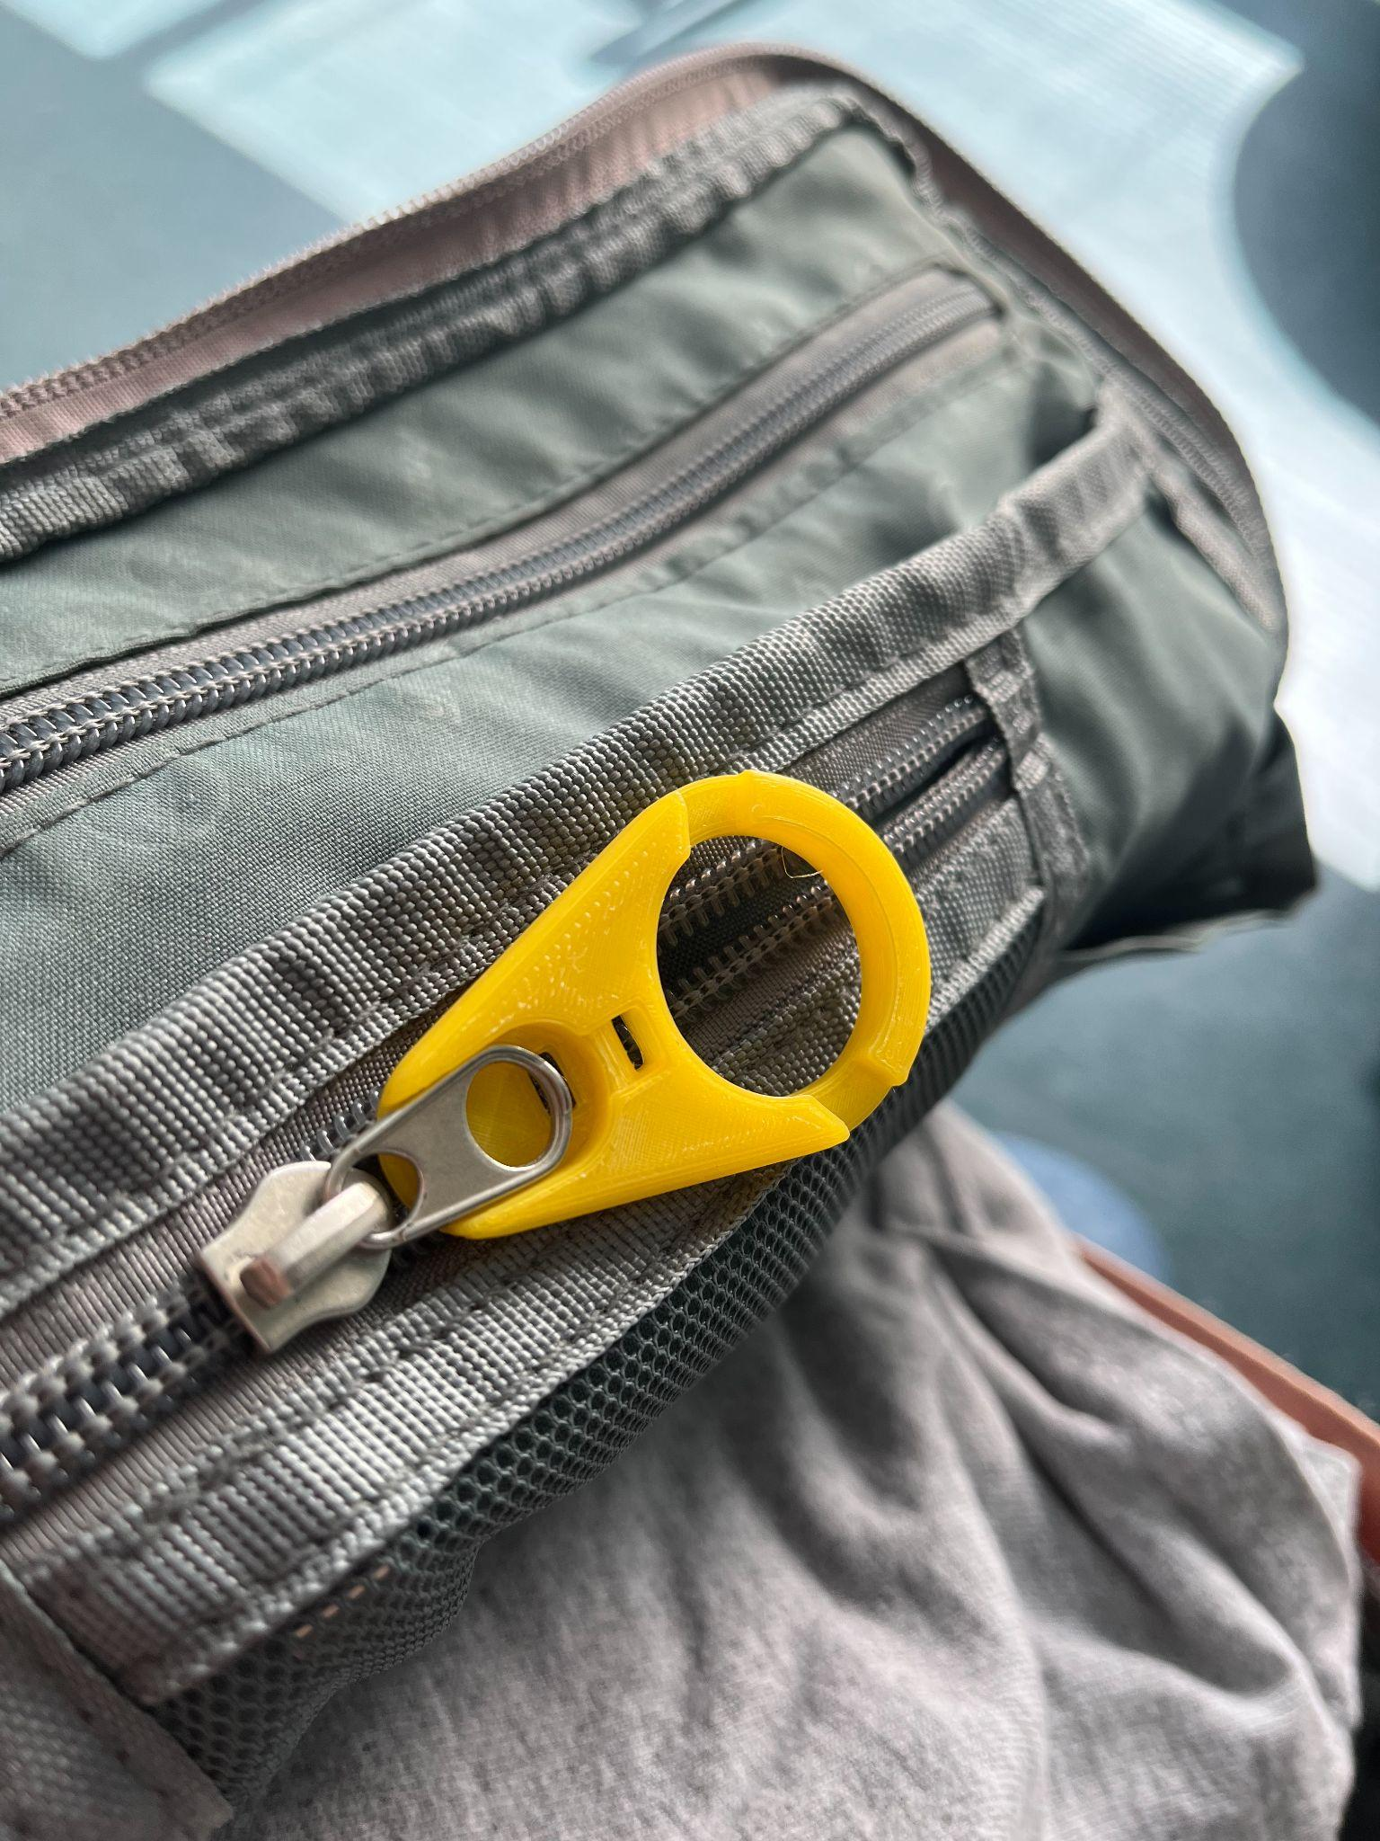
Zipper Aid B

Description: A device that makes it easier to use a zipper. It increases the size of the zipper and provides a larger hole allowing for a better grip. The zipper aid is attached using zip ties. Version B is the medium size available and fits a larger zipper size.
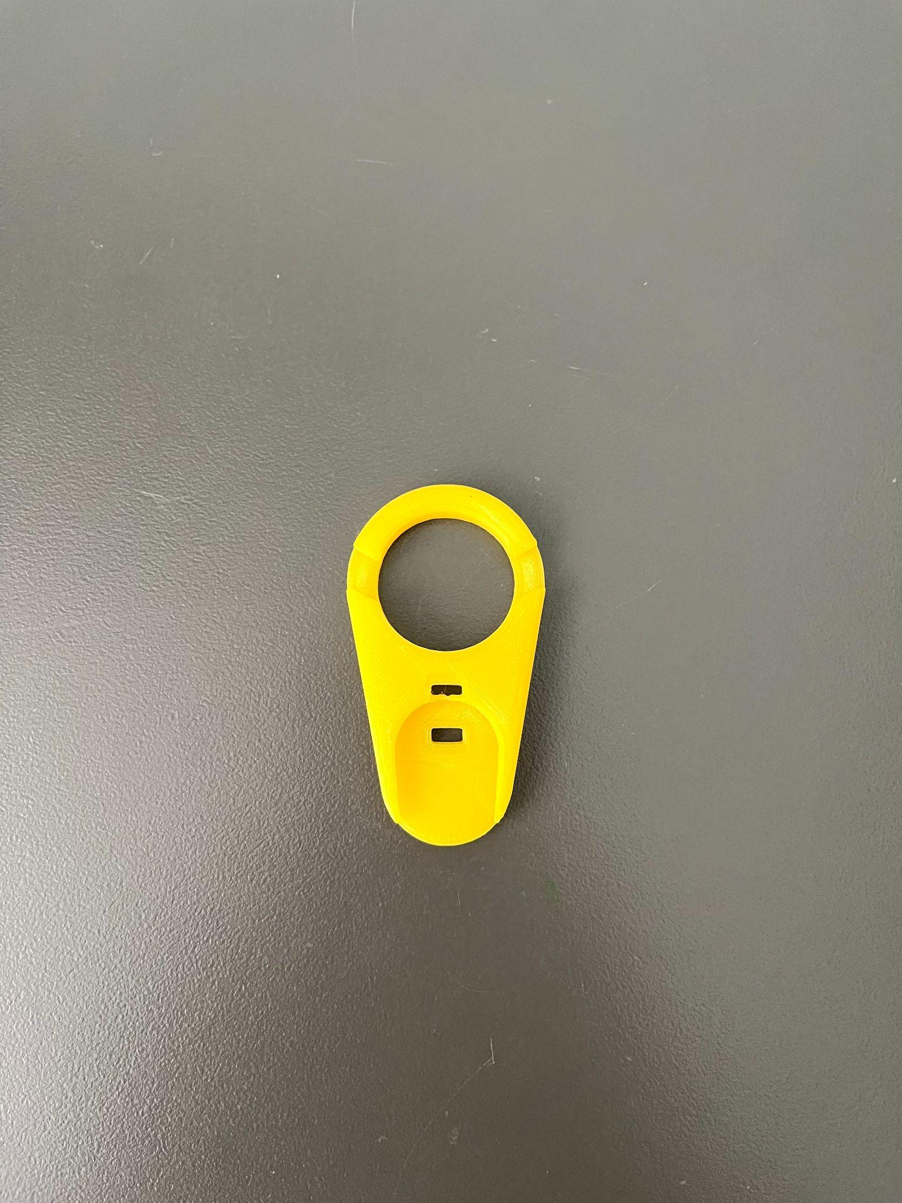
Zipper Aid C
Description: device that makes it easier to use a zipper. It increases the size of the zipper and provides a larger hole allowing for a better grip. The zipper aid is attached using zip ties. Version C is the largest one available and fits a smaller zipper size.
